Section A

- Explain why crude oil is described as a mixture.

__________________________________________________________________________________________
__________________________________________________________________________________________

- Choose the fraction of crude oil that has the lowest boiling point.
Tick ( ) one box.
- Bitumen | 
- Petrol
- Liquefied petroleum gases

- Choose the option that correctly describes the pattern of viscosity in the fractions of crude oil.
Tick ( ) one box.
- Viscosity increases as the size of molecules in a fraction increase
- Viscosity decreases as the size of molecules in a fraction increase
- Viscosity increases as the size of molecules in a fraction decrease

- The image below shows a fractionating column.

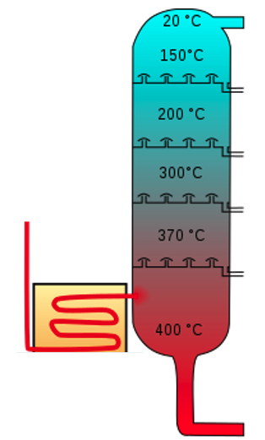
- Add labels to the fractionating column to show where it is hottest and coolest.

- Add labels to the fractionating column to name each of the fractions collected at each condenser.

Section B

- Fractional distillation is used to separate crude oil.
- Describe how fractional distillation separates crude oil.

__________________________________________________________________________________________
__________________________________________________________________________________________
__________________________________________________________________________________________
__________________________________________________________________________________________

- Describe the relationship between the size of molecules in a fraction and boiling point.

__________________________________________________________________________________________
__________________________________________________________________________________________

- Explain the relationship between the size of molecules in a fraction and boiling point.

__________________________________________________________________________________________
__________________________________________________________________________________________
__________________________________________________________________________________________
__________________________________________________________________________________________

- The table below shows the boiling points of three alkanes.

Alkane | Boiling point (ºC)
Pentane (C₅H₁₂) | 36
Decane (C₁₀H₂₂) | 174
Pentadecane (C₁₅H₂₂) | 271

- What is an alkane?

__________________________________________________________________________________________
__________________________________________________________________________________________

- What is the general formula for alkanes?

__________________________________________________________________________________________

- Determine which state of matter pentane would be at room temperature (22 ºC).

__________________________________________________________________________________________
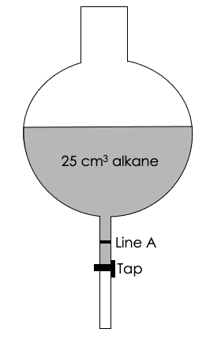
A student used the following experiment to investigate a property of these alkanes:

- Add 25 cm³ of pentane to a separating flask (as shown)
- Start the timer as the tap is opened
- Record the time taken for the level of pentane to reach line A
- Repeat for decane and pentadecane

- What property is the student investigating with this experiment?

________________________________________________________

- The student measured 5.2 seconds for pentane to reach line A.

Predict how the time taken for decane and pentadecane would compare.

Explain your answer.

__________________________________________________________________________________________
__________________________________________________________________________________________
__________________________________________________________________________________________
__________________________________________________________________________________________

Section C

- Fractional distillation is used to separate crude oil into fractions, but there are many other uses of distillation.

- Describe how distillation is used in desalination.
- Give a disadvantage of using distillation for desalination.
- Give the name for water that is safe to drink.
- Explain the difference between water that is safe to drink and distilled water.
- Explain whether distilled water would conduct electricity.
- Draw a dot and cross diagram to show the bonding in water.
- Calculate the percentage by mass of oxygen in water.

